Instructions : Select the appropriate language version below (EN/NL/FR), then copy and paste it into your Outlook signature settings. Please ensure the coloured banner appears below the text. The IT team can assist you if needed. Don’t forget to replace the placeholder text with your own contact details.

English:

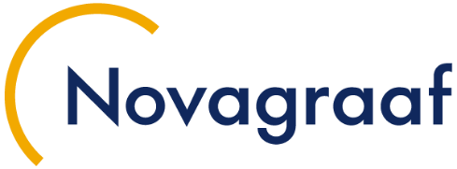 | First-name LASTNAME  Job Title 1  Job Title 2, if not delete this line
Novagraaf London | 1st Floor | 77 Gracechurch Street | LONDON EC3V 0AS
United Kingdom | +44 (0)20 7469 0950| f.lastname@novagraaf.com | Disclaimer



Nederlands:

Voornaam Achternaam
Job Title 1
Job Title 2, if not delete this line
Novagraaf Nederland B.V. |Hoogoorddreef 5 | 11001 BA Amsterdam | Amsterdam
Nederland | +31 (0)20 564 14 11| f.lastname@novagraaf.com | Disclaimer


Français :

Consultez tout notre flash info dédié à la PI sur Nova IP Hour.
Prénom NOM
Job Title 1
Job Title 2, if not delete this line
Novagraaf France | 2 rue Sarah Bernhardt | CS90017-92665 | Asnières-sur-Seine Cedex
France | +33 (0)1 49 64 60 00| f.lastname@novagraaf.com | Disclaimer


