Instructions: Select the appropriate language version below (EN/NL/FR), then copy and paste it into your Outlook signature settings. Please ensure the colored banner appears below the text. The IT team can assist you if needed. Don’t forget to replace the placeholder text with your own contact details.

English:

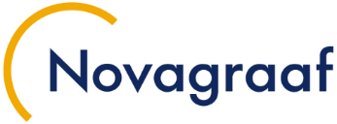 | First-name LASTNAME  Job Title 1  Job Title 2, if not delete this line
Novagraaf London | 1st Floor | 77 Gracechurch Street | LONDON EC3V 0AS
United Kingdom | +44 (0)20 7469 0950| f.lastname@novagraaf.com | Disclaimer



Brandstock Legal signatures:

 | First-name LASTNAME  Job Title 1  Job Title 2, if not delete this line
Brandstock Legal Rechtsanwaltsgesellschaft mbH, part of the Novagraaf Network
Möhlstraße 2 | 81675 Munich | Germany | T. +49 89 599 185 30
f.lastname@brandstock.com | www.novagraaf.com | Disclaimer

Registered Office: 81675 Munich
German Companies Register: Amtsgericht Muenchen | HRB 239618
Managing Director: Alessia Parassina


Netherlands:

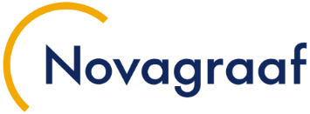 | Voornaam ACHTERNAAM  Job Title 1  Job Title 2, if not delete this line
Novagraaf Nederland |Hoogoorddreef 5 | 1101 BA | Amsterdam
Nederland | +31 (0)20 564 14 11| f.lastname@novagraaf.com | Disclaimer


Netherlands EN banner:

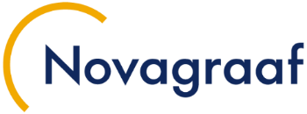 | Voornaam ACHTERNAAM  Job Title 1  Job Title 2, if not delete this line
Novagraaf Nederland |Hoogoorddreef 5 | 1101 BA | Amsterdam
Netherlands | +31 (0)20 564 14 11| f.lastname@novagraaf.com | Disclaimer

Français :

Consultez tout notre flash info dédié à la PI sur Nova IP Hour.
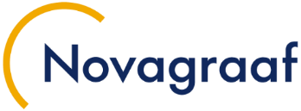 | Prénom NOM  Job Title 1  Job Title 2, if not delete this line
Novagraaf France | 2 rue Sarah Bernhardt | CS90017-92665 | Asnières-sur-Seine Cedex
France | +33 (0)1 49 64 60 00| f.lastname@novagraaf.com | Disclaimer


Français EN banner :

Prénom NOM
Job Title 1
Job Title 2, if not delete this line
Novagraaf France | 2 rue Sarah Bernhardt | CS90017-92665 | Asnières-sur-Seine Cedex
France | +33 (0)1 49 64 60 00| f.lastname@novagraaf.com | Disclaimer

